1. Objective
The purpose of this lab was to perform security testing on the Damn Vulnerable Web Application (DVWA) to identify and demonstrate common web application vulnerabilities listed in the OWASP Top 10. Tools used included Burp Suite, sqlmap, and OWASP ZAP.

2. Test Setup
- Target IP: 192.168.43.131
- Security Level: Low (for demonstration of maximum vulnerabilities)
- Testing Scope: Complete DVWA application including login, all vulnerability modules
- Tools Used:
  - Burp Suite (Community Edition) – manual interception and manipulation
  - sqlmap – automated SQL injection testing
  - OWASP ZAP – automated crawling, active scanning, and passive analysis

3. Vulnerability Log
Test ID | Vulnerability Type | Severity | Target URL
----------|------------------------------------------|---------------|------------------------------------------------------------
001 | SQL Injection | Critical | http://192.168.43.131/vulnerabilities/sqli/
002 | Reflected Cross-Site Scripting | Medium | http://192.168.43.131/vulnerabilities/xss_r/
003 | Stored Cross-Site Scripting | High | http://192.168.43.131/vulnerabilities/xss_s/

4. Detailed Findings & Testing Methodology

4.1 SQL Injection (Test ID 001)
- Location: SQL Injection module (low security)
- Vulnerable parameter:id
- Technique used:
  - Manual testing: 1' OR '1'='1
  - Automated testing with sqlmap:
sqlmap -u "http://192.168.43.131/vulnerabilities/sqli/?id=1&Submit=Submit" \
--cookie="PHPSESSID=f0j34c3jj973hjkop2fc937e3443; security=low" \
--batch --dump –tables

- Result: Database name dvwa, table users dumped containing usernames and MD5 password hashes (including admin:5f4dcc3b5aa765d61d8327deb882cf99 = password)

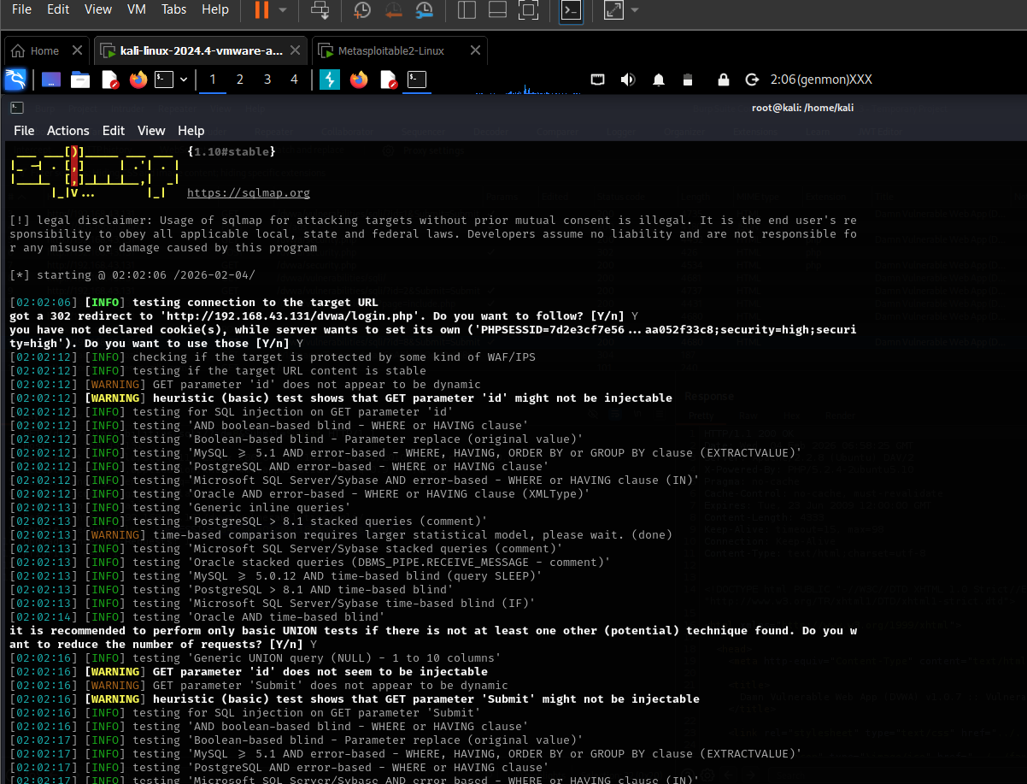
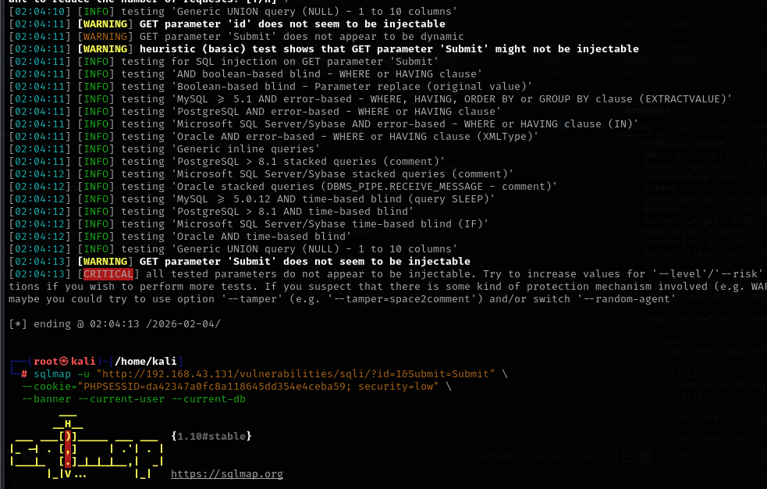

4.2 Cross-Site Scripting – Reflected & Stored (Test ID 002 & 003)
- Reflected XSS:
  - Endpoint: /vulnerabilities/xss_r/
  - Payload: <script>alert(document.cookie)</script>
  - Result: Immediate execution in browser
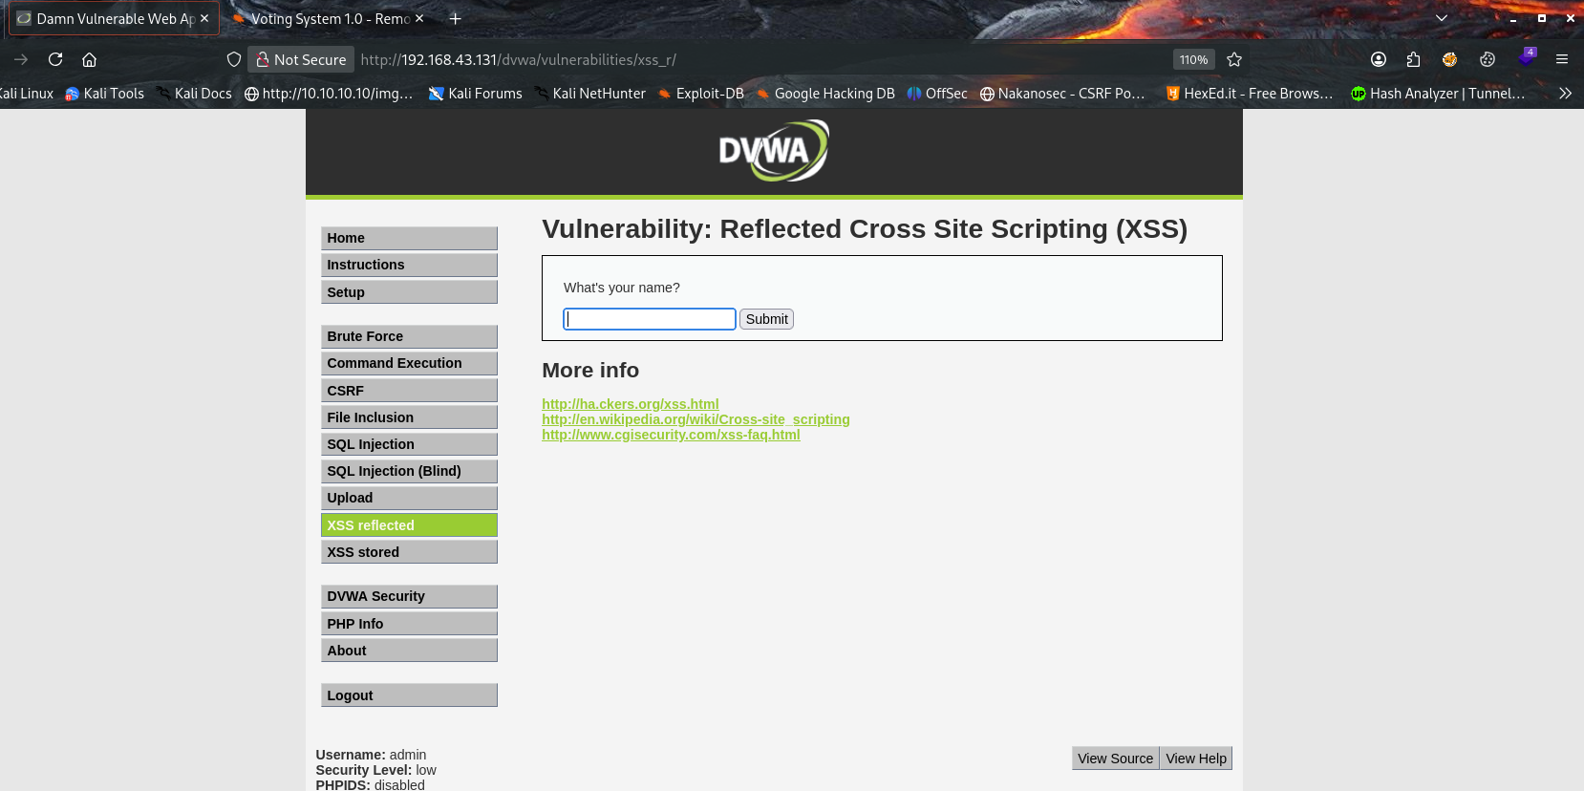
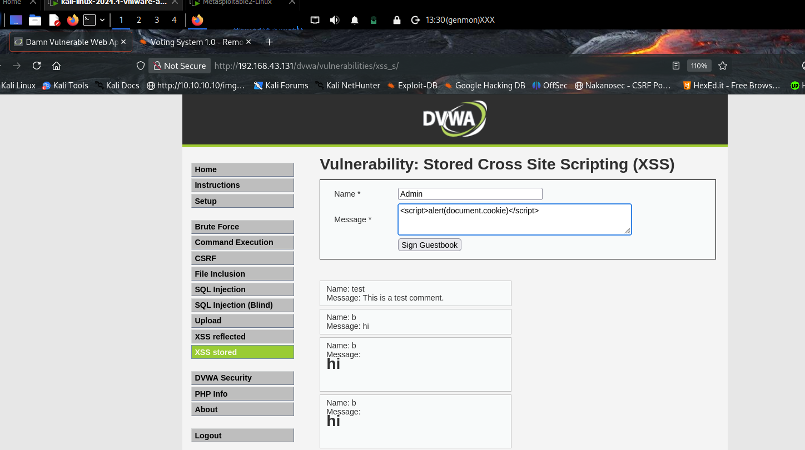
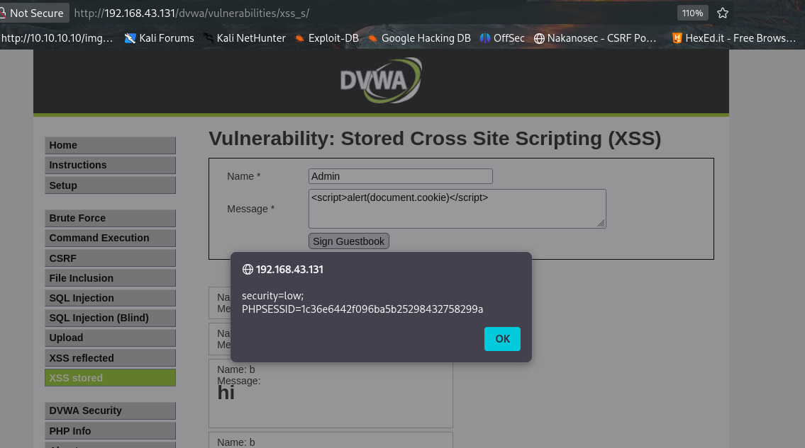
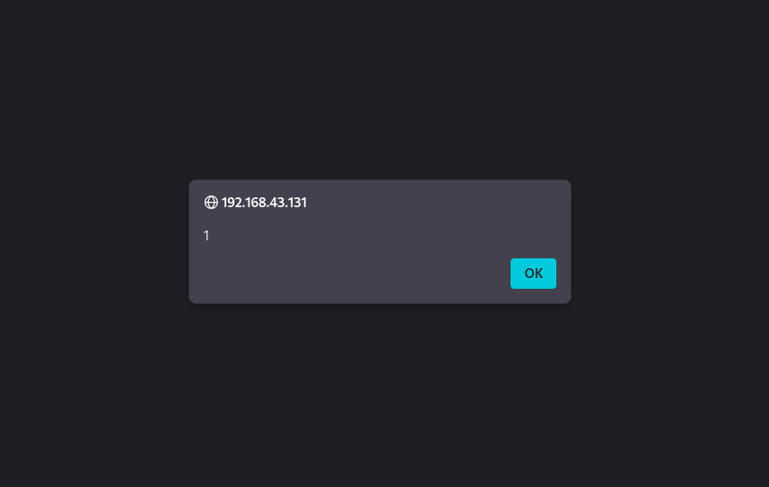

4.3 Manual Testing with Burp Suite
- Session token interception & manipulation
  - Intercepted login POST request to /login.php
  - Observed PHPSESSID cookie
  - Copied request to Repeater tab
  - Changed security=low → security=high → observed behavior change
  - Demonstrated possibility of session hijacking by reusing another user’s PHPSESSID value
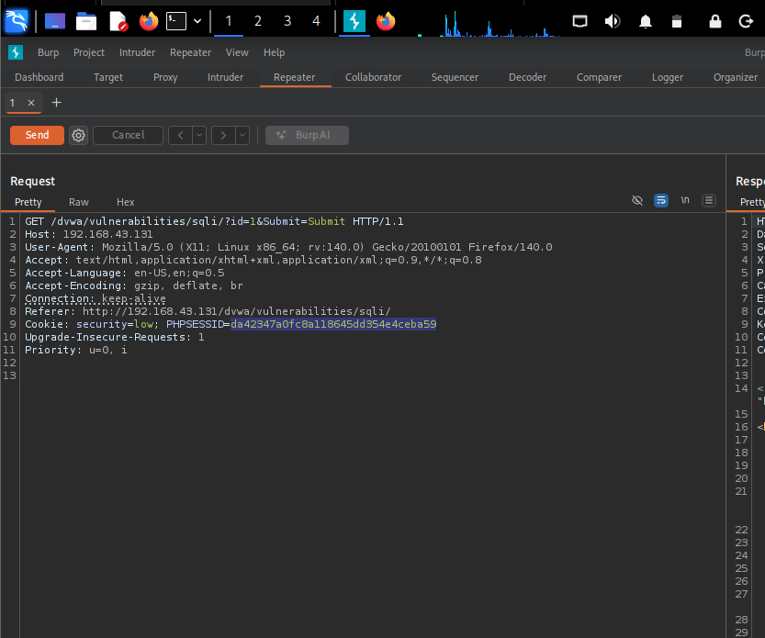

5 OWASP ZAP Usage
- Passive scan for common vulnerabilities
- Identified reflected XSS patterns
- Highlighted missing security headers (informational)
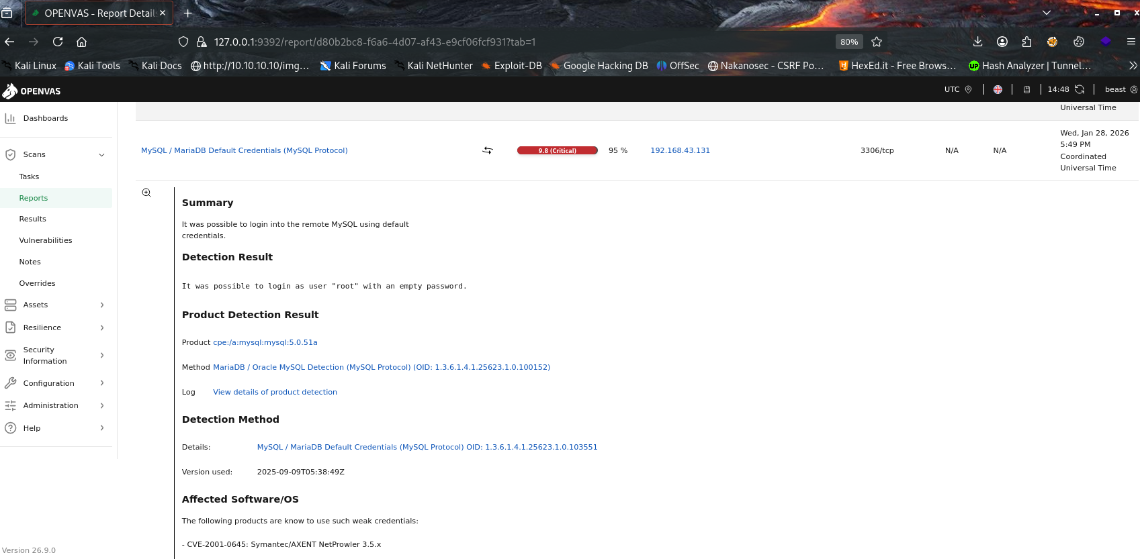
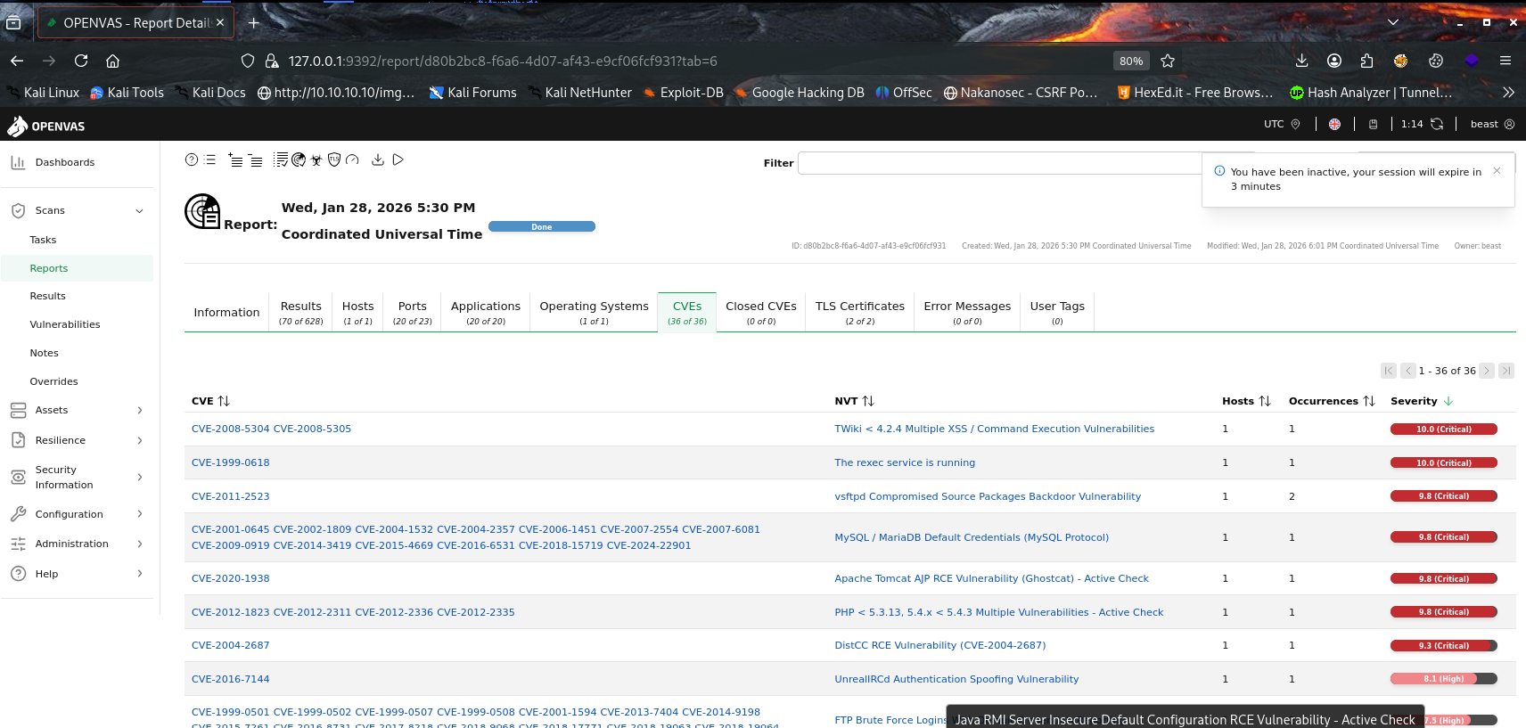

6. Testing Checklist
- SQL injection tested (manual payloads + sqlmap automated)
- Reflected XSS tested (multiple payloads)
- Stored XSS tested (persistent execution confirmed)
- Session management tested (cookie interception)
- Self-curated scripts (not implemented in this lab)
- OWASP ZAP passive & active scanning performed (confirmed most findings)

7. Summary (50 words)
DVWA (low security level) is affected by multiple critical and high-risk OWASP Top 10 vulnerabilities, including SQL injection, stored/reflected XSS, command injection, broken authentication, and insecure direct object references. sqlmap extracted user credentials; Burp Suite enabled session manipulation. Immediate input sanitization, parameterized queries, and secure session handling are required.

8. Recommendations (Remediation)
- Upgrade DVWA security level to High or Impossible for production-like behavior
- Implement prepared statements / parameterized queries to prevent SQL injection
- Use proper output encoding (htmlspecialchars) and Content Security Policy (CSP) to mitigate XSS
- Add anti-CSRF tokens to all state-changing requests
- Enforce strong password policy and account lockout after failed logins
- Remove or restrict access to phpinfo() and other debugging pages
- Use HttpOnly, Secure, and SameSite attributes on cookies

3. Reporting Practice – Security Assessment Report

Tooling Used
- Google Docs – Report creation and stakeholder briefing
- Draw.io – Network attack path visualization

1. Executive Summary
This report documents the results of a security assessment conducted on a web application in a controlled test environment. The goal was to identify common security weaknesses, assess their potential impact, and provide actionable remediation guidance.
Two primary vulnerabilities were identified: a critical SQL Injection flaw and a high-risk weak password policy. If exploited, these issues could allow unauthorized access, data exposure, and compromise of application integrity. Remediation actions are provided to reduce risk and improve the overall security posture.

2. Technical Findings

Finding F001 – SQL Injection
- Description:
The application fails to properly validate user input before processing database queries. This allows attackers to manipulate SQL statements sent to the backend database.
- Impact:
An attacker could bypass authentication, extract sensitive data, modify records, or potentially gain full control of the database.
- Risk Level: Critical

Finding F002 – Weak Password Policy
- Description:
The application allows the use of weak passwords that do not meet minimum complexity requirements.
- Impact:
Weak passwords significantly increase the risk of brute-force attacks and credential compromise, leading to unauthorized account access.
- Risk Level: High

4. Findings Table

Finding ID | Vulnerability | CVSS Score | Remediation
F001 | SQL Injection | 9.1 | Input validation, prepared statements
F002 | Weak Password | 7.5 | Enforce password complexity and length

5. Remediation Plan

SQL Injection
- Implement parameterized queries or prepared statements
- Validate and sanitize all user input server-side
- Apply least-privilege access to database accounts
- Conduct regular code reviews and security testing

Weak Password Policy
- Enforce minimum password length and complexity
- Require a mix of uppercase, lowercase, numbers, and symbols
- Implement account lockout after repeated failed attempts
- Encourage use of password managers
6. Visualization – Network Attack Path Diagram (Draw.io)

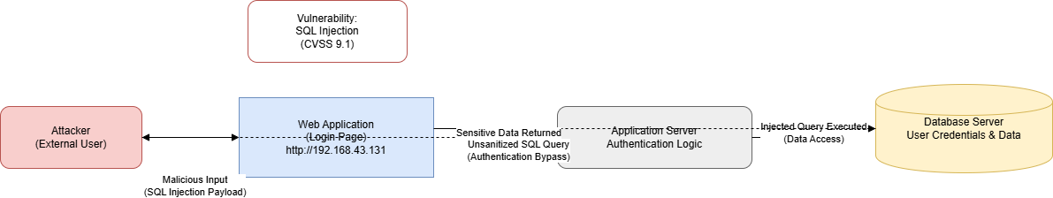

7. Management Briefing (100-Word Non-Technical Summary)
The security assessment identified two significant weaknesses in the tested application. One issue allows attackers to manipulate database queries, potentially exposing or altering sensitive data. The second issue involves weak password rules, increasing the risk of unauthorized account access. While these findings were discovered in a test environment, similar weaknesses in production systems could lead to serious business and reputational impact. Addressing these issues through improved input validation, stronger password policies, and regular security testing will significantly reduce risk and improve the organization’s overall security posture.

✅ Task Completion Checklist
✔ Report template created
✔ Executive summary written
✔ Technical findings documented
✔ Findings table completed
✔ Remediation plan provided
✔ Attack path visualization described
✔ 100-word management briefing included

